BIOL 2510 Learning Objectives 5AB

Lecture 5A
- Describe the skin and hair changes associated with aging and define elastosis.
The skin starts to change in color and this is due to the pigment called melanin which hair follicles produce. These structures on the skin make and grow hair. During aging this follicles makes less melanin and this causes grey hair.
Elastosis refers to certain changes in the dermal tissue with increased deposition of elastic materials.
- Contrast the types of primary skin lesions. (Table provided.)

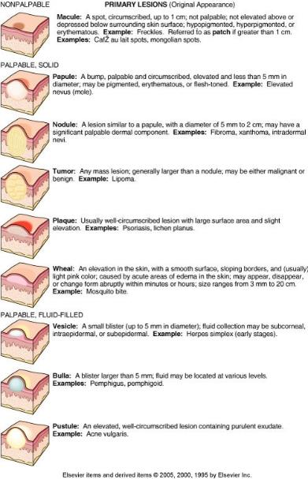

PRIMARY LESIONS | DESCRIPTION
Macule | A spot, circumscribed up to 1cm; not elevated above or depressed below surrounding skin surface; hypopigmented, hyperpigmented.  Example: Freckles. Refers to as patch of greater than 1cm
Papule | It is a bump, palpable and circumscribed, elevated and less than 5mm in diameter. It may be pigmented, erythematous or flesh-toned.  Example: Elevated nevus.
Nodule | It is a lesion similar to papule with a diameter of 5mm to 2cm. It may have a significant palpable dermal component.  Example: Fibroma, xanthoma and intradermal nevi.
Tumor | It is any mass lesion that is generally larger than a nodule. It may be either malignant or being.  Example: lipoma.
Plaque | It is usually well-circumscribed lesion with large a larger surface area and slight elevation.  Example: psoriasis, lichen planes.
Wheal | It is an elevation in the skin with a smooth surface, sloping borders and usually light pink in color. It is caused by acute areas of edema in the skin. It also may appear, disappear or change form abruptly within minutes or hours. Its size changes from 3mm to 20cm.  Example: Mosquito bite.
Vesicle | It is as a small blister up to 5mm in diameter. The fluid collection may be sub corneal, intraepidermal or sub epidermal.  Example: Herpes simplex in early stages.
Bulla | It is a blister larger than 5mm. The fluid may be located at various levels.  Example: Pemphigus, pemphigoid.
Pustule | An elevated and well-circumscribed lesion containing purulent exudate.  Example: Acne vulgaris.

- Contrast the types of secondary skin lesions. (Table provided.)

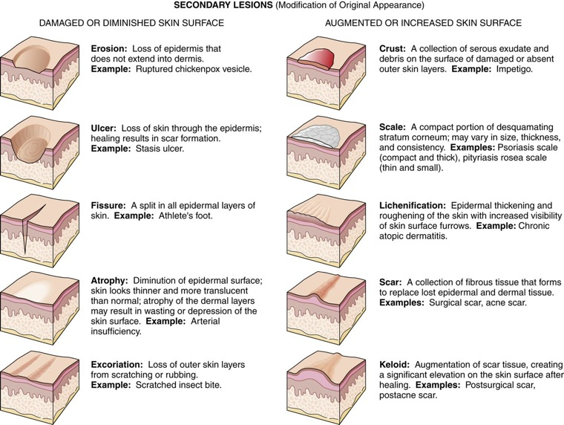

SECONDARY LESIONS | DESCRIPTION
DAMAGED OR DIMISHED SKIN SURFACE
Erosion | Loss of epidermis that does not extend into dermis.  Example: Ruptured chickenpox vesicle.
Ulcers | This is loss of skin through the epidermis and healing results in scar formation.  Example: Stasis ulcers.
Fissure | It is a split in all epidermal layer of the skin.  Example: Athlete’s foot.
Atrophy | Diminution of epidermal surface. The skin looks thinner and more translucent than normal. Atrophy of the dermal layers may result in wasting or depression of the skin surface.  Example: Arterial insufficiency.
Excoriation | This is loss of the outer skin layer from scratching or rubbing.  Example: Scratched insect bite.
AUGUMENTED OR INCREASED SKIN SURFACE
Crust | This is a collection of serious exudate and debris on the surface of the damaged or absent outer skin layers.  Example: Impetigo.
Scale | It is a compact portion of desquamating stratum cornea. It may vary in size, thickness and consistency.  Examples: Psoriasis scale which is compact and thick, pityriasis rosea scale which is thin and small.
Lichenification | This is epidermal thickening and roughening of the skin with increased visibility of the skin surface furrows.  Example: Chronic atopic dermatitis.
Scar | This is a collection of fibrous tissue that forms to replace lost epidermal and dermal tissue.  Examples: Surgical scar and acne scar.
Keloid | This is augmentation of scar tissue, creating a significant elevation on the skin surface after healing.  Examples: Postsurgical scar and postacne scar.

- List and define the terms used to describe the body location of skin lesions.
Primary skin lesions, these are the abnormal skin conditions which are presented at birth they are also acquired over a person’s lifetime.
Secondary skin lesions, these they result from manipulated primary lesions or irritated.

- List the names of the skin infections in this module and state whether each is causes by a virus, a bacterium or a fungus.
Viral skin infections
Chickenpox
Warts
Molluscum contagiosum
Measles
Mouth, foot and hand disease

Fungal skin infections
Athletes’ foot
Ringworm
Diaper rash
Oral trash
Yeast infection

Bacterial skin infection
Leprosy
Impetigo
Boils
Cellulitis

- Contrast viral infections that cause integumentary lesions with respect to lesion appearance/rash location and other manifestations: HPV, HSV types 1, 2, 3,6,7,8, rubella, Rubeola and roseola. (Table provided)
Virus | Lesion Description | Rash Location | Other Manifestations
Human Papilloma Virus  (HPV) | Papules known as verrucae (warts) | Usually on hands or feet | Strains that cause warts are not the same as strains that cause cervical cancer.
Herpes Simplex Virus  (HSV) Type 1 and Type 2 | A progression occurs from vesicles to pustules to ulcers to crusts over a period of 10-14 days. | HSV type 1 infects above the waist (cold sores, for example)  HSV type infects the genital area and is sexually transmitted. | HSV persists in a dormant state in nerve ganglia and may cause recurrent infection at any time.
Herpes Simplex Virus  (HSV) Type 3 (Varicella-Zoster) | A progression occurs from vesicles to pustules to ulcers to crusts over a period of 10-14 days. | Chicken pox is a childhood form of the infection.  Shingles is a recurrence of infection. The rash occurs along the spinal nerve dermatomes causing pain along the dermatome. The lesion progression takes 2 to 3 weeks. | HSV persists in a dormant state in nerve ganglia and may cause recurrent infection at any time.  Post-herpetic neuralgia (persistence of dermatomal pain long after infection clears) is a possible complication of shingles.  Eye involvement may cause blindness.
Rubella Virus  (German measles) | Confluent pruritic maculopapular light red rash | The rash begins on the face and moves downward. The face clears as the rash moves inferiorly. | A TORCH infection capable of causing congenital defects (cataracts, deafness, heart anomalies) if it occurs in the mother early in pregnancy.  It may cause miscarriage.  May be accompanied by low-grade fever  Prevented by MMR vaccine
Rubeola Virus  (Red Measles aka Hard Measles) | Confluent flat (macular), red or brownish rash; usually not pruritic | The rash begins on the face and moves downward. The face clears as the rash moves inferiorly. | Accompanied by a high fever  Complications such as blindness, pneumonia or brain inflammation occur in 30%.  Prevented by MMR vaccine
Herpes Simplex Virus  Type 6 or Type 7  (Roseola Infantum aka Sixth Disease) | Spots or patches of maculopapular pink rash: not pruritic. | The rash begins on the trunk and moves to the face and arms. Legs may or may not be affected. | Occurs only in children, usually before age 2  Rash appears after a 3-day fever of greater than 103 degrees F.  Recurrence is rare.

- Contrast fungal infections that cause integumentary lesions with respect to specific causative organism and lesion appearance/rash locations: tinea capitis, tinea corpis, tinea barbae, tinea pedis, thrush, intertrigo, chronic mucocutaneous candidiasis and onychomycosis.
Tinea capitis: This is a fungal infection of the scalp and hair shafts. The infection is caused by a fungi called dermatophytes and the infection appears itchy patches on the scalp.
Tinea corpis: This infection that is likes to be in moist areas of the body like skin folds. The infection appears circular or round in shape and may be black or red in color.
Tinea barbae: This is a fungal infection that usually attacks the areas of the face with a dermatophyte fungus. The infection is caused by T. verruscosum that comes from cattle or T. metagrophytes var. equinum that originates from horses.
Tinea pedis: The infection usually grows between the toes which normally becomes sweaty. The infection appears scaly with red rash. Tinea pedis is caused by the same fungus that causes ringworms and jock itch.
Thrush: It is a yeast infection grows in the mouth, throat and other parts of the body. The thrush looks like white and raised lesions on the tongue and cheeks. The infection is caused by overgrowth of the fungus called Candida.
Intertrigo: It is infection that mostly affects the folds of the skin and it appears reddish-brown rash .Intertigo is caused by skin folds sitting together and rubbing together of the skin.
Chronic mucocutaneous candidiasis c: It is an infection that comes as a result of variation of vaginal bacteria. The infection is caused by overgrowth of candida.
Onychomycosis. This is an infection that causes thickening and separation of the nail. The infection is caused by the organism called dermatophytes. The infection majorly affects the nails.

- Contrast bacterial infections that cause skin lesions with respect to specific causative organism, lesion appearance and locations and treatment: impetigo and acne vulgaris.
Impetigo is an infection that mainly affects infants and small children. The infection appears as reddish sores on the face especially around the nose and mouth. Impatigo is caused by a bacteria called staphylococci organisms. Once the infection has been noticed the antibiotics are treated to limit the spread of the infection to others.
Acne vulgaris occurs when the hair follicles are blocked with dead skin cells, bacteria and sebum. The infection is caused by the combination of hormones, oil and bacteria. The infection is treated over-the-counter topical medicine in creams, gel and washes with benzoyl peroxide.
- Describe the difference between an open comedone and a closed comedone.
Open comedone is as a result of surface pigments collecting in the pores forming dark spots on the skin.
Closed comedones is formed because the hair follicles is completely blocked.
- Contrast the local and systemic treatments for acne vulgaris.
Acne vulgaris is locally treated through the combination of benzoyl peroxide, oral and topical antibiotics and a topical retinoid.
The acne is systematically treated by topical therapy to get rid of antibiotics that have proved to be the most effective such as tetracycline, vibramycin and minocin.

Lecture 5B
- Contrast non-infective skin disorders with respect to etiology and lesion appearance/locations: systemic lupus erythematosus, chronic discoid lupus erythematosus, seborrhea dermatitis, psoriasis and pemphigus. (Table provided)
Disorder | Etiology | Rash Description/Location
Systemic Lupus Erythematosus  (SLE) | Autoimmune response to the human nuclear material causing systemic disease  LE cell positive | Red, macular, scale-like, lesions  Occurs on the face in a butterfly (malar) pattern: cheek-nose-cheek), arms, fingers, legs; usually symmetric  No scarring or pigment loss
Chronic Discoid Lupus Erythematosus | Not associated with systemic symptoms  LE negative | Red, scale-like well-circumscribed plaques that are elevated at the edges  Occurs on the face (malar pattern) scalp, ears, arms, chest; may not be symmetric  Scarring, pigment loss and hair loss may occur.
Seborrhea dermatitis  Cradle cap in infants  Dandruff in adults | Unclear, but appears to be related to a heightened immune response to normal flora fungi of the genus Malassezia. | Reddened patches of greasy skin covered with flaky white or yellow scales or crusts occur where sebaceous glands are plentiful, usually on the head and face, but also
Psoriasis | Unclear, but appears to involve immune stimulation of epidermal keratinocytes. | Papules and patches with a silvery scale occur on knees, elbows, lower back, scalp, and nails.
Pemphigus | Autoantibodies are produced against keratinocytes and basement membrane components.  A combination of Type II (cytotoxic) and Type III (immune complex) hypersensitivity | Bullae erupt on skin and mucous membranes.  Without treatment (corticosteroids) infection and toxemia are dangerous complications.

- Identify non-infective skin disorders from photos.
Psoriasis
Seborrheic dermatitis
Reiter’s syndrome

- Contrast malignancies of the skin with respect to cell type of origin, lesion appearance and likelihood of metastasis: basal cell carcinoma, squamous cell carcinoma, malignant melanoma and Kaposi sarcoma.
Basal cell carcinoma: This is the type of the ski cancer. It originated in the basal cells that are within the skin which produces new cells as the old ones die. The cell appears as a transparent bump on the skin and it occurs when the skin is often exposed to the sun.
Squamous cell carcinoma: This is a skin cancer that develops in the squamous cells that make up the middle and outer layers of the skin. The cells comes out as a result of prolonged exposure ultraviolent radiation.
Malignant melanoma: This is the type of the skin cancer that develops from melanocytes pigment producing cells. It is caused by exposure to ultraviolent light to those with level of skin pigment melanin.
Kaposi sarcoma: This is a form of cancer that tumor with blood vessels that grow below the surface of the skin, in the mouth, nose, eyes and anus. They appear painless spots that are red and they are itchy and do not drain.
- Describe the diagnostic importance of actinic keratosis.
Because actinic keratosis represents the earlier manifestation of skin cancer and this leads to a risk of progression of invasive squamous cell carcinoma, then earlier diagnosis and treatment are necessary.
- Identify skin cancer types from photos:
Basal cell carcinoma, squamous cell carcinoma, malignant melanoma
- Define each letter in the ABCDE Rule for Malignant melanoma.
A-asymmetry.
B-border
C-color
D-diameter
E-evolving
- Describe the etiology and progression of xeroderma pigmentosum (XP).
The xeroderma pigmentosum is caused by mutation of genes that are used in repairing of damaged DNA. This can be damaged by UV rays from the sun and by toxic chemicals.
- If the mother and the father of an unborn child are both carriers for XP, what is the probability that the child will be affected by XP? (Punnett square required.)

X P
XX | XP
XP | PP
X

P
If both parents are XP carriers, they must pass on gene mutation for a child to be affected. Since both parents are carriers of a recessive mutation in the same gene there is the probability that a child will inherit two mutations and be affected.

- Contrast disorders of epidermal proliferation with respect to etiology, appearance and location: ichthyosis, corns and calluses.
Ichthyosis: It is a condition that causes widespread and persistent thick skin. The skin of a person suffered from ichthyosis is dry, rough and scaly and needs to be regularly moisturized.
Corns: They are smaller and they have hard center surrounded by inflamed skin. Corns tends to grow on parts of the feet that don’t bear weight like toes. They appear thick and rough.
Calluses: They usually grow on the soles of the feet especially under the feet. Calluses appear larger and they vary in size and shape.

- Contrast skin lesions caused by arthropod bites with respect to type of arthropod, bite lesion appearance/locations: mites, lice and bed bugs.
Mite: This is an eight-legged arthropods that are tiny and have simple segmented body plan. Many of them live in the soil as decomposers. Other species live in water and others in plants.
Lice: This is a parasitic insect that is tiny and feeds on human blood. The parasite spread through close personal contact or by sharing belongings. They are different type and these different types are found in different locations.
Bed bugs: These are small parasites that majorly feed on the blood of warm blooded animals. The insects normally are found under beds and hide within clothes. They normally bite when one is asleep.
- Contrast tick-borne bacterial infections with respect to causative organism, lesion appearance/location and other manifestations: Lyme disease (all stages) and Rocky Mountain fever.
Lyme disease: This is an infectious disease that is caused by a bacterium called Borrelia. The infection is spread by ticks. It appears to be a red rash when bitten and the rash is itchy and painful.
Rocky Mountain fever: This is a bacterial disease that is spread through the bite of an infected tick. The fever is caused by the infection with the organism Rickettsia rickettsii. The rash normally appears on the wrists and ankles.

- Distinguish between the effects of UVA and UVB light on skin cells.
UVA light can penetrate into the skin more intense and cause the skin cells to grow prematurely while UVB rays have higher energy levels and typically damage the outermost layer of the skin and this causes sunburn. The UVB rays damages DNA and this is the cause of skin cancer.

- List the sunscreen chemicals that protect against both UVA and UVB rays.
Tinosorb S and M
Mexorly
Oxybenzone
Octinoxate
Avobenzone
Titanium dioxide
- Describe the etiology and prevention of decubitus ulcers.
Decubitus ulcers is caused by prolonged pressure with other factors like poor circulation and poor nutrition. The ulcers are prevented by using supporting items like pillows that reduce pressure over points.
- Describe the etiology and treatment of vitiligo.
Vitiligo is a skin infection that causes the skin to lose color. This occurs when the skin cells that produce melanin are destroyed by the body immune system. Vitiligo is treated by creating a uniform skin tone by restoring the skin color. The other treatment includes regimentation therapy and surgery.

